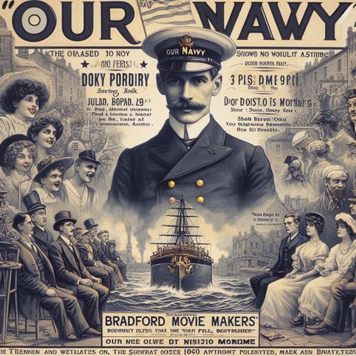

Monday March 11th 2024
Visiting Speaker at the Club

David Clover

Talk entitled: "Sea Salts and Celluloid"
Alfred J. West F.R.G.S.
"Our Navy"1897-1913".... I was the first to see the possibilities of such an invention
in connection with marine subjects."
(A.J.West - Kinematograph Weekly 01/03/1917)

